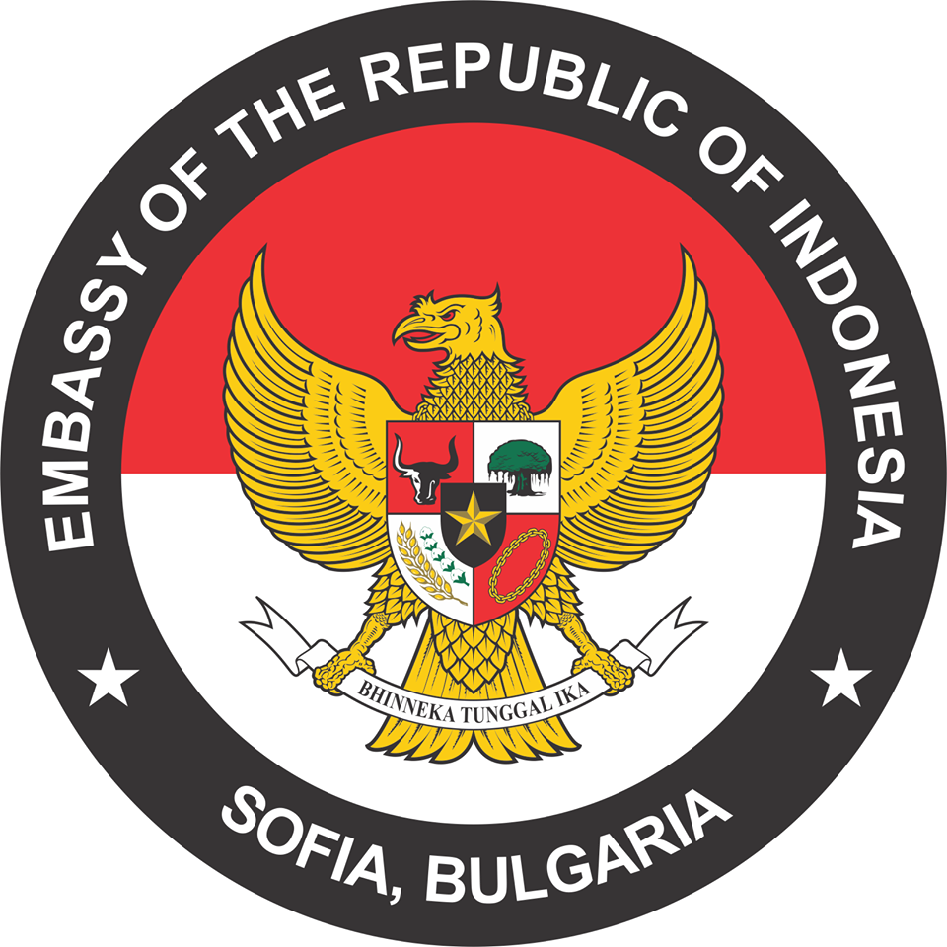


Meetings with Indonesian companies
7 November 2023

Hall A, fl.1. BCCI / 9 “Iskar” Str./

10.00 – 10.30 | Official opening
 | Address by Mr. TSVETAN SIMEONOV, President of the Bulgarian Chamber of Commerce and Industry
 | Address by H.E. Mr. IWAN BOGANANTA, Ambassador Extraordinary and Plenipotentiary of Indonesia to Bulgaria
10.30 – 11.00 | Presentation of the Indonesian companies
11.00 – 13.00 | B2B meetings

Working languages: English

